Course Name: Advanced Programming

Course Code: 3CS362

HOSPITAL MANAGEMENT SYSTEM

Pratiksha Gawali (2017BTECS00011)

Sujata Jadhav (2017BTECS00095)

Sanyogeeta Kamle (2017BTECS00059)

Idea:

Hospitals currently use a manual system for the management and maintenance of critical information. The current system requires numerous paper forms, with data stores spread throughout the hospital management infrastructure. Multiple copies of the same form information exist in the hospital and may lead to inconsistencies in data in various data stores. Our project Hospital Management System includes registration of patients, storing their details into the system, maintaining the visitor’s info and maintaining the occupancy of the different wards. It includes the search facility to know the patient’s and the visitor’s info and also the current status of each room. The Hospital Management System can be accessible either by an administrator or receptionist. Only they can add data into the database. The interface is user friendly. The data is well protected for personal use and makes the data processing very fast.

Flowchart:

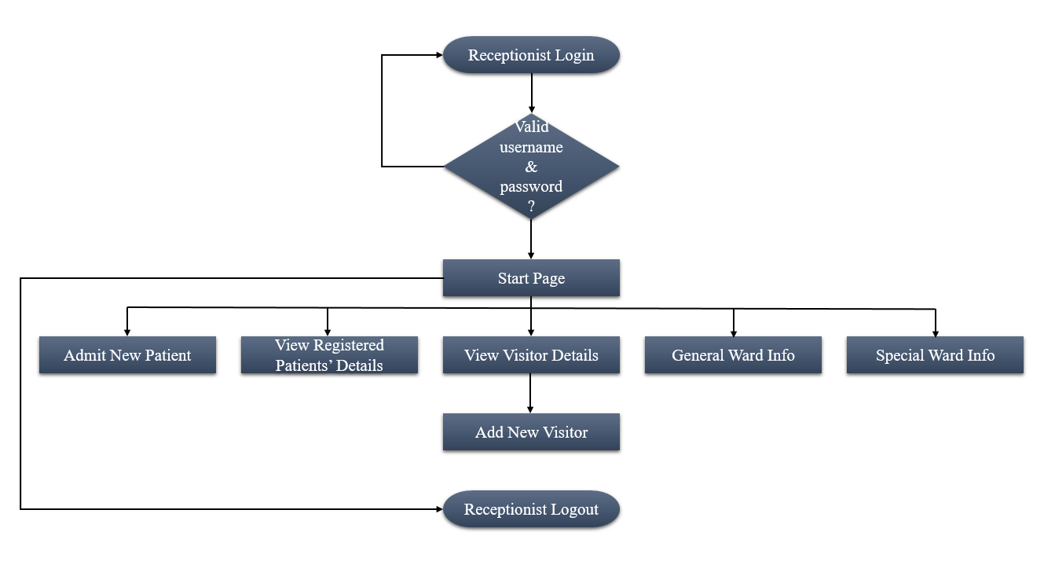

Technologies Used:

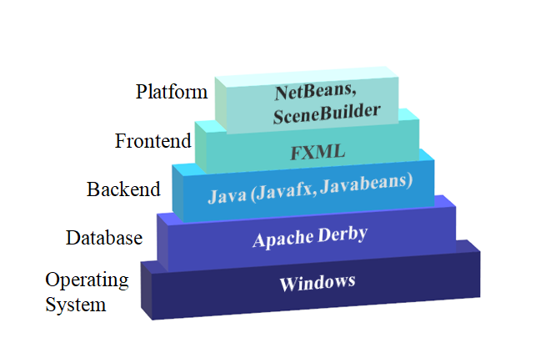

Applications:

It is a user-friendly application which reduces the burden of maintaining the paper forms and the registers and helps to manage the sections of hospital like reception, inpatient/outpatient management which improves the processing efficiency. It improves data security, avoid errors and track every single detail and establish the hospital to be a technically advanced one.

Conclusion:

Since, we are entering details of the patients electronically in the hospital management system, data will be secured. Using this application, we can retrieve patient’s history with a single click. Thus, processing information will be faster. It guarantees accurate maintenance of patient details. It easily reduces the book keeping task and thus reduces the human effort and increases the accuracy speed. Future scope includes digitally storing the patient’s records.